**Name:**   ID: :

**Department of Computer Science and Engineering**

**CSE 330: Numerical Methods**

**Quiz 1 FALL 2018**

**Full Marks: 10 SET A**

Solve the following equation using an iterative approach upto ***3*** iterations. Also find the *absolute relative true* *error*, $\left|∈_{t}\right|\%$ after each iteration. Suppose, you are given an initial guess of $x_{o}=2$.

$e^{2x}+cos \left(2x\right)-6=0$

*Graphical representation of the given equation:*

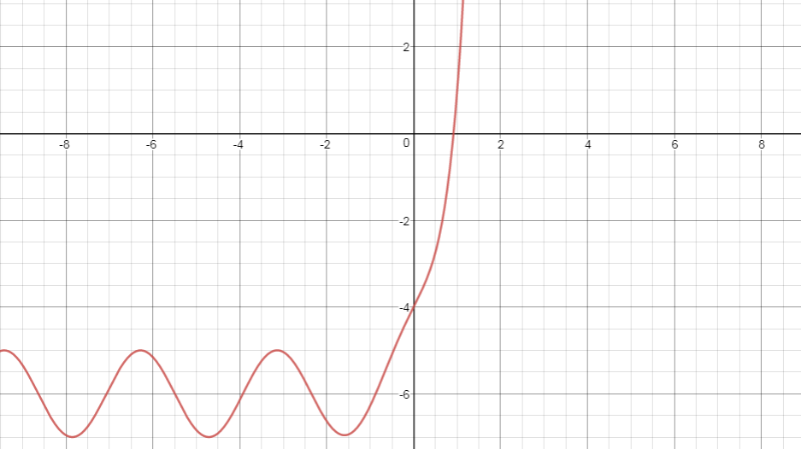

Bisection Method: $x_{m}=\frac{x_{l}+x_{u}}{2}$  
False Position Method: $x_{r}=\frac{x_{u} f\left(x_{l}\right)-x_{l} f\left(x_{u}\right)}{f\left(x_{l}\right)-f\left(x_{u}\right)}$

Newton Raphson’s Method: $x_{i+1}=x_{i}-\frac{f(x_{i})}{f'(x_{i})}$